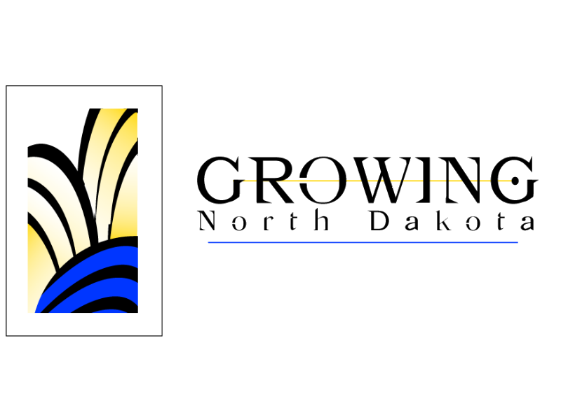
North Dakota Workforce Development Council

“Making Good Things Happen for North Dakotans"

MINUTES

UNIFIED STATE PLANNING WORKGROUP
MARCH 20, 2002

The regular meeting of the Unified State Planning Workgroup was held Wednesday, March 20, 2002, at the Fort Totten Room, State Capitol, and Bismarck.

MEMBERS PRESENT: Connie McBride, Dave Massey, Carol Griffin-Eckert, Cheryl Penny, and Jim Hirsch.

MEMBERS ABSENT: Korrine Lang, Dawn Anderson, Gene Hysjulien, Wayne Kutzer, Lee Starken, Eddie Dunn, Tex Hall, Charles Murphy, Richard Monette, Allan McKay, David Gipp, Cheryll McDowall, and Dan Marrs.

OTHERS PRESENT: Jean Bennette with Experience Works from South Dakota.

Introductions: Jim Hirsch welcomed everyone and everyone introduced themselves.

Work Group Responsibilities: Jim Hirsh noted that the Workgroup was reorganized and had not met for some time. One member from each of the partner agencies has been invited to participate on the Workgroup. A smaller workgroup will allow each partner to have a voice. Objectives for the first meeting are to develop a planning calendar and to review the purpose and scope of the workgroup. Based on results of a One-Stop Delivery System survey, there is also a need to develop recommendations for improvement of partnership communication at both the state and at the point of service delivery level.

Memorandum of Understanding/One Stop System Survey: In November, a survey was sent out to all the partners. 8 out of 16 responses came back with a variety of answers. There has been turn over within the partner agencies and therefore lack of understanding about the One-Stop Delivery System. The survey also identified issues with communication at both the state and local level. In some area’s the communication was very good and in other areas there was no communication. There was also information regarding the Client Referral Information System (CRIS). If CRIS was not being used, it was because there was no knowledge of such a system.

We need to work on a plan on how to brief the agency and partner administrators, how we orientate and train staff both at the state level and at the local level, and how to schedule follow-ups to that orientation facilitate improvement of communication.

The Workgroup needs to discuss changes or modifications for the Five-Year State Strategic Plan and the Memorandum of Understanding (MOU). Currently all of the partners have signed the MOU except for the Three Affiliated Tribes. Jim will continue to work with them to get their support.

Jim provided an overview of the Workgroups purpose, responsibilities, and duties. He noted that the Strategic Plan should be a living, working, document that will continually change.

According to the By-Laws, the Unified State Plan Working Group shall be responsible for:
- Advise and make recommendations to the North Dakota Workforce Development Council (NDWDC) on employment and training policy;
- Provide recommendations and input into development of the Strategic Five-Year State Workforce Development Plan;
- Provide recommendations on performance indicators under the Workforce Investment Act;
- Provide recommendations and input into development of the Memorandum of Understanding under the Workforce Investment Act; and
- Play a role in the education of mandatory partners and promotion of coordination and cooperation of the North Dakota Workforce Development Delivery System.

Dave Massey suggested that the Workgroup have a discussion on how this whole thing works in North Dakota with details including, where the money comes from, who is the administrator of this fund, who is the funds distributor, how much money goes where, what programs are supported by each. Tie in names and dollars. Jim noted that a good place to start would be with each of the partners identifying how they are doing it and what kind of resources are being put behind it.

Connie McBride noted that case workers and reception people don’t have knowledge of all of tools available. Training is needed for the people on the front lines, better promotion for CRIS. Dave mentioned that he is not familiar with CRIS at all. Jim noted that not only is the issue of what CRIS is but how to access it.

CRIS (Client Referral Information System): Jim noted that the discussion has already been going regarding CRIS. He mentioned that he will pursue more discussion on CRIS and identify any gaps that each partner might have in delivery of their services and then identify how the clients can access CRIS. From there the Workgroup can identify how to support the system and market it. CRIS was the first step in electronically linking the One-Stop Delivery System Partners. The second phase that was talked about was how to share common data, so that applicants wouldn’t have to provide each agency with the same data. Dave Massey noted that until the Data warehouse is implemented it is impossible to keep, for instance, 6 different databases updated. Information Technology Department is looking at some unified system of keeping the information. Carol Griffin-Eckert noted that confidentiality is a big issue for most agencies. An idea that came from the discussion is that quarterly reminders go out to a designated person, from each of the partners, asking is your page current on CRIS.

United State General Accounting Office Reports: Jim Hirsh discussed the WIA Improvements Needed in Performance Measures to Provide a More Accurate Picture of WIA’s Effectiveness report. Jim also discussed the coordination between TANF and One-Stop Centers. Jim will send a copy of this report to everyone.

Incentive Planning: Jim Hirsh noted that the state will be able to participate in the incentive awards. The minimum is $750,000. That is the amount that the council has been looking at. Two critical pieces is having the information go before the Council and input from the Legislature. The only time the information could come from the Legislature is when they are having interim meetings in April. The Council wants to come up with an assessment of needs across the state to identify those pockets where there are unmet needs, then match them up with opportunities within the state.

Plan Modification: Jim discussed the memo that he received from the Department of Labor.

Memorandum of Understanding Modification: This is included in your packet for your information.

Negotiated Levels of Performance Guidance: This was included for your information. Jim noted that states do have the ability to request modification to the performance indicators for the next year.

Planning Calendar: Jim Hirsh reviewed the suggested planning calendar. It was suggested that the Workgroup meet monthly until issues are in order, at that time move the meetings to every other month, if not quarterly. Jim noted that in regards to the calendar, it is perpetual. We will start with the May/June issues and repeat it every year. Jim noted how important it will be to develop the recommendation so that information can go to the council.

ACTION ITEMS:
- Jim will work with the Three Affiliated Tribes on becoming a partner to the MOU.
- Jim will send a copy of the report of the comparison of TANF and One-Stop Centers.
- Each partner will be asked to provide a profile on the programs and services they deliver as core, intensive and training services under the One-Stop System.
- Develop an orientation plan and communication plan to train and create awareness of the One-Stop Delivery System.
- Each partner bring forward anything that would help educate the Council on the services that the partner is delivering and the projects they are involved in.

NEXT MEETING: The next meeting of the Unified State Planning Workgroup will be May 16, 2002, starting at 10:00 AM, at the Roosevelt Park Room, State Capitol, Bismarck.

Respectfully Submitted

James J. Hirsch
Director

